**Module (JAVASCRIPT BASIC & DOM) – 4**

Q.1 What is JavaScript?

Ans: JavaScript is the scripting and programming language for the Web.JavaScript is a multi-paradigm, dynamic language with types and operators, standard built-in objects, and methods. Its syntax is based on the Java and C languages — many structures from those languages apply to JavaScript as well. JavaScript supports object-oriented programming with object prototypes and classesthreaded. It is also known as the scripting language for webpages. It is well-known for the development of web pages, and many non-browser environments also use it.

Q.2 What is the use of isNaN function?

Ans: In JavaScript, NaN is short for “not a number”. In JavaScript, NaN is a number that is not a legal number. The Global NaN property is the same as the Number. Nan property.To tell if a value is NaN , use Number. isNaN() or isNaN() to most clearly determine whether a value is NaN — or, since NaN is the only value that compares unequal to itself, you can perform a self-comparison like x !== x . For more information about NaN and its comparison, see Equality comparison and sameness.

Q.3 What is negative Infinity?

Ans: The **negative infinity** in JavaScript is a constant value that is used to represent a value that is the lowest available. This means that no other number is lesser than this value. It can be generated using a self-made function or by an arithmetic operation.

Q.4 Which company developed JavaScript?

Ans: JavaScript is a programming language used in web development. It was developed by Netscape to add dynamic and interactive elements to websites. JavaScript is influenced by Java. It is a client-side scripting language.

Q.5 What are undeclared and undefined variables?

Ans: Undefined variable means a variable has been declared but does not have a value. Undeclared variable means that the variable does not exist in the program at all.

Q.6 Write the code for adding new elements dynamically?

Ans: The innerHTML property is used to write the HTML code using JavaScript dynamically.

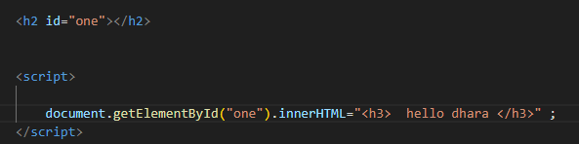

Q.7 What is the difference between ViewState and SessionState?

Ans: **View state**

State management is on the client side.

Data is accessible within the same web page.

It's less secure.

**Session state**

State management is on the server side.

Data is accessible from other web pages of the website.

It's more secure.

Q.8 What is === operator?

Ans: Compares the inequality of two operands with type. If both value and type are equal then the condition is true otherwise false.

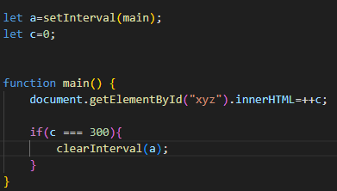

Q.9 How can the style/class of an element be changed?

Ans: className property sets the class name of an element. This property can be used to return the value of the class attribute of an element. We can use this property to add a class to an [HTML](https://www.javatpoint.com/html-tutorial) element without replacing its existing class. The javascript uses html elements like id, class, name, and other elements to identify the user input field. We can change the style, like width, alignment, color, border, background color, and other properties. We can change, add or remove any CSS property from an HTML element on the occurrence of any event with the help of JavaScript.



We can change, add or remove any CSS property from an HTML element on the occurrence of any event with the help of JavaScript.

Q.10 How to read and write a file using JavaScript?

Ans: The read and write operations in a file can be done by using some commands. But the module which is required to perform these operations is to be imported. The required module is 'fs' which is called as File System module in JavaScript.

Q.11 What are all the looping structures in JavaScript?

Ans: The JavaScript loops are used to iterate the piece of code using for, while, do while or for-in loops. It makes the code compact. It is mostly used in array

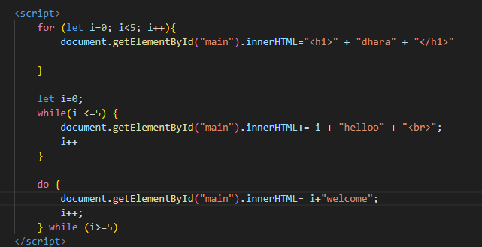

Q.12 How can you convert the string of any base to an integer in JavaScript?

Ans: In JavaScript, To convert a string to an integer [parseInt()](https://www.tutorialspoint.com/es6/es6_numberparseint.htm), Number(), and Unary operator (+) function is used in JavaScript. converting a string to an integer means transforming a string that represents a numeric value into an actual integer data type. This is useful when you need to perform arithmetic operations or comparisons on numeric values stored as strings

Q.13 What is the function of the delete operator?

Ans: The delete operator in JavaScript removes a property from an object. It can delete both own properties and inherited properties. Using delete on an array item leaves a hole.

Q.14 What are all the types of Pop up boxes available in JavaScript?

Ans: It is used when a warning message is needed to be produced. When the alert box is displayed to the user, the user needs to press ok and proceed.

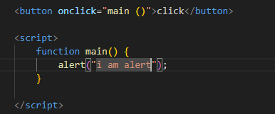

Q.15 What is the use of Void (0)?

Ans: javascript: void(0) means return undefined as a primitive value. We use this to prevent any negative effects on a webpage when we insert some expression.

Q.16 How can a page be forced to load another page in JavaScript?

Ans: in javascript  you can force a page to load another page by using the window.location object. There are a few methods to achieve this. To force a page to load another page in JavaScript, we have multiple approaches.

Q.17 What are the disadvantages of using innerHTML in JavaScript?

Ans: The **innerHTML**property in JavScript is used to append the dynamic HTML or text content to an element using javascript. It is designed to add dynamic HTML, but developers also use it to add text content as well. It can be directly used with the element by selecting it using DOM manipulation.